| **CO3** | **Implement various algorithms of Regression and Classification.** |
| --- | --- |
| **Task5**: | Build a model using any of the classification algorithms that can effectively analyze and classify a new sample. Calculate the classification rate, accuracy, precision, and recall for your data set.  **Platform: Alteryx Google co-lab, Language: Python** |

**Use Case: Titanic Dataset**

**Objective:**

The objective of this use case is to develop a machine learning model that predicts the direction of Titanic data set.

**Dataset:**

The dataset contains the following fields: Pclass, Sex, Age, SibSp, Parch, Fare, Embarked.

Algorithm:   
1. Load the dataset from the specified file path.

2. Create a new column 'Survive'.

3. Split the dataset into training and testing sets.

4. Initialize a different Classifiers.

5. Train the classifiers using the training data.

6. Make predictions on the test set.

7. Calculate accuracy, precision, recall, and confusion matrix.

8. Print the results.

9. Plot the Confusion Matrix Heatmap.

10. Plot the Precision-Recall Curve.

12. Plot a Bar plot of Accuracy, Precision, and Recall.

**Program:**

import pandas as pd

import seaborn as sns

from sklearn.model_selection import train_test_split

from sklearn.tree import DecisionTreeClassifier

from sklearn.ensemble import RandomForestClassifier

from sklearn.metrics import classification_report, accuracy_score, precision_score, recall_score, confusion_matrix, roc_curve, auc, precision_recall_curve

import matplotlib.pyplot as plt

# Load Titanic dataset

titanic = sns.load_dataset("titanic")

# Preprocess the data

titanic.dropna(subset=['age', 'embarked'], inplace=True)

X = titanic[['pclass', 'sex', 'age', 'sibsp', 'parch', 'fare', 'embarked']]

X = pd.get_dummies(X, columns=['sex', 'embarked'], drop_first=True)

y = titanic['survived']

# Split the data into training and testing sets

X_train, X_test, y_train, y_test = train_test_split(X, y, test_size=0.2, random_state=42)

# Decision Tree Classifier

dt_classifier = DecisionTreeClassifier(random_state=42)

dt_classifier.fit(X_train, y_train)

y_pred_dt = dt_classifier.predict(X_test)

# Random Forest Classifier

rf_classifier = RandomForestClassifier(n_estimators=100, random_state=42)

rf_classifier.fit(X_train, y_train)

y_pred_rf = rf_classifier.predict(X_test)

# Calculate metrics for Decision Tree

classification_rep_dt = classification_report(y_test, y_pred_dt)

accuracy_dt = accuracy_score(y_test, y_pred_dt)

precision_dt = precision_score(y_test, y_pred_dt)

recall_dt = recall_score(y_test, y_pred_dt)

print(f'Accuracy: {accuracy_dt}')

print(f'Precision: {precision_dt}')

print(f'Recall: {recall_dt}')

# Confusion Matrix for Decision Tree

cm_dt = confusion_matrix(y_test, y_pred_dt)

sns.heatmap(cm_dt, annot=True, fmt='d', cmap='Blues', cbar=False)

plt.title('Confusion Matrix - Decision Tree')

plt.xlabel('Predicted')

plt.ylabel('Actual')

plt.show()

print('Confusion Matrix:\n', cm_dt)

# Precision-Recall Curve for Decision Tree

precision_dt, recall_dt, _ = precision_recall_curve(y_test, dt_classifier.predict_proba(X_test)[:, 1])

plt.figure(figsize=(8, 6))

plt.plot(recall_dt, precision_dt, color='blue', label='Decision Tree')

plt.xlabel('Recall')

plt.ylabel('Precision')

plt.title('Precision-Recall Curve - Decision Tree')

plt.legend()

plt.show()

# Calculate metrics for Random Forest

classification_rep_rf = classification_report(y_test, y_pred_rf)

accuracy_rf = accuracy_score(y_test, y_pred_rf)

precision_rf = precision_score(y_test, y_pred_rf)

recall_rf = recall_score(y_test, y_pred_rf)

print(f'Accuracy: {accuracy_rf}')

print(f'Precision: {precision_rf}')

print(f'Recall: {recall_rf}')

# Confusion Matrix for Random Forest

cm_rf = confusion_matrix(y_test, y_pred_rf)

sns.heatmap(cm_rf, annot=True, fmt='d', cmap='Blues', cbar=False)

plt.title('Confusion Matrix - Random Forest')

plt.xlabel('Predicted')

plt.ylabel('Actual')

plt.show()

print('Confusion Matrix:\n', cm_rf)

# Precision-Recall Curve for Random Forest

precision_rf, recall_rf, _ = precision_recall_curve(y_test, rf_classifier.predict_proba(X_test)[:, 1])

plt.figure(figsize=(8, 6))

plt.plot(recall_rf, precision_rf, color='green', label='Random Forest')

plt.xlabel('Recall')

plt.ylabel('Precision')

plt.title('Precision-Recall Curve - Random Forest')

plt.legend()

plt.show()

print()

**Output:**

Accuracy: 0.7132867132867133

Precision: 0.6896551724137931

Recall: 0.6349206349206349

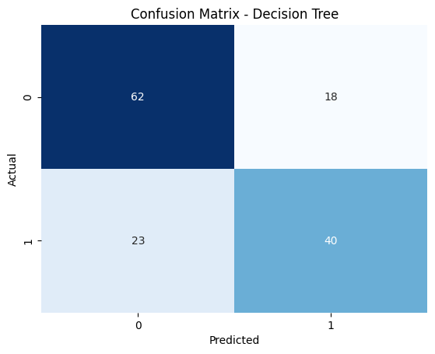

Confusion Matrix:

[[62 18]

[23 40]]

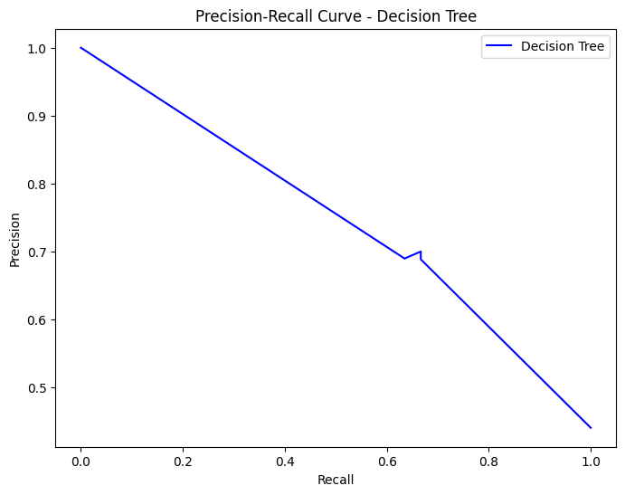

Accuracy: 0.7622377622377622

Precision: 0.7543859649122807

Recall: 0.6825396825396826

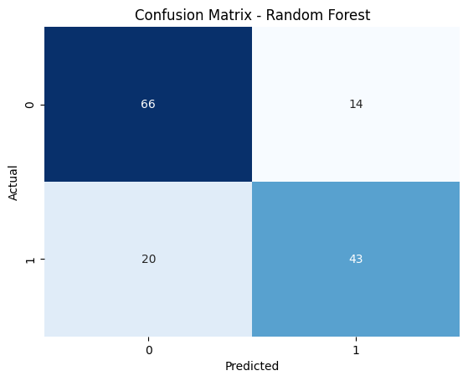

Confusion Matrix:

[[66 14]

[20 43]]

